***Open-CV in python:***

***What is Open-CV Library?***

*Open-CV, short for Open Source Computer Vision Library, is an open-source computer vision and machine learning software library. Originally developed by Intel, it is now maintained by a community of developers under the Open-CV Foundation.*

# *Introduction to Open-CV*

*Open-CV is one of the most popular computer vision libraries. If you want to start your journey in the field of computer vision, then a thorough understanding of the concepts of Open-CV is of paramount importance.*

*In this article, to understand the basic functionalities of Python Open-CV module, we will cover the most basic and important concepts of Open-CV intuitively:*

1. *Reading an image*
2. *Extracting the RGB values of a pixel*
3. *Extracting the Region of Interest (ROI)*
4. *Resizing the Image*
5. *Rotating the Image*
6. *Drawing a Rectangle*
7. *Displaying text*

* *Let’s start with the simple task of reading an image using Open-CV.*

*For the implementation, we need to install the Open-CV library using the following command:*

***Pip install opencv-python***

## ***2.1Working with Images:***

*Reading an image in Open-CV using Python*

*In this article, we’ll try to open an image by using OpenCV (Open Source Computer Vision) library.*

* ***The required libraries:***

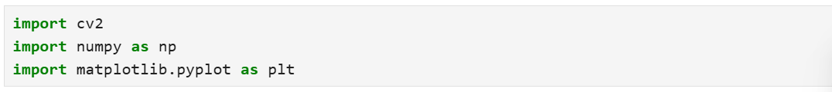

* ***Example 01:***
* ***Output:***

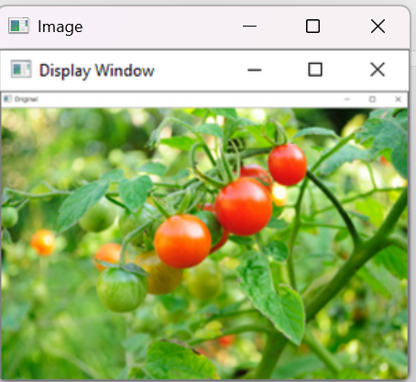

* ***Example 02:***
* ***Output:***

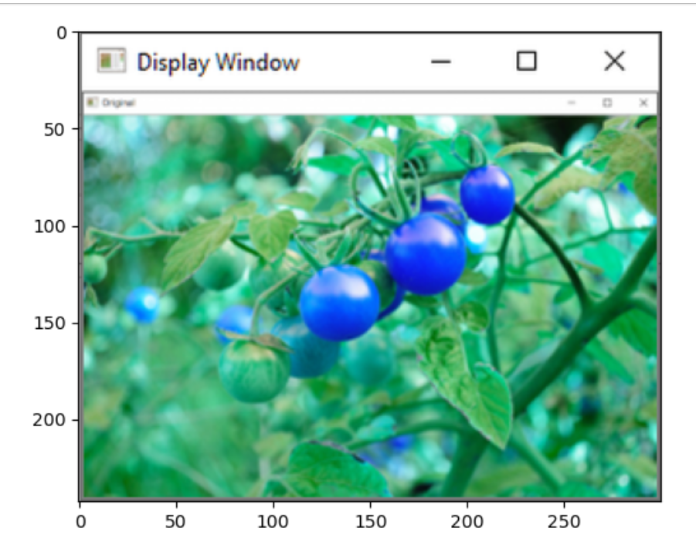

# *Arithmetic Operations on Images using Open-CV | Set-2 (Bitwise Operations on Binary Images)*

*Bitwise operations are used in image manipulation and used for extracting essential parts in the image. In this article, Bitwise operations used are :*

1. ***AND***
2. ***OR***
3. ***XOR***
4. ***NOT***

### ***Bitwise AND operation on Image:***

* ***Output:***

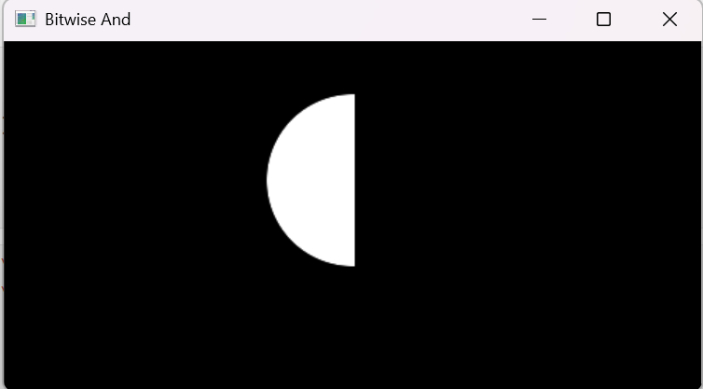

### ***Bitwise OR operation on Image:***

* ***Output:***

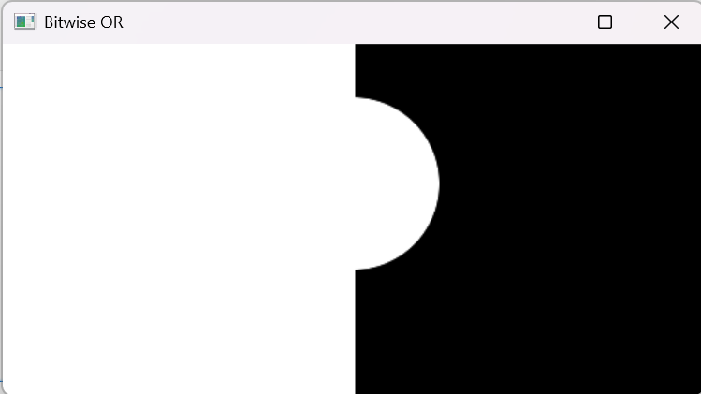

### ***Bitwise XOR operation on Image:***

* ***Output:***

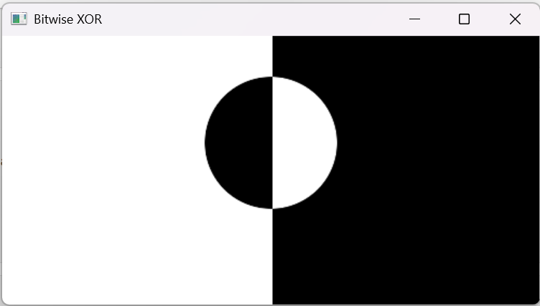

# *Color Spaces in Open-CV | Python*

# *****Color spaces******are a way to represent the color channels present in the image that gives the image that particular hue. There are several different color spaces and each has its own significance. Some of the popular color spaces are RGB (Red, Green, Blue), CMYK (Cyan, Magenta, Yellow, Black), HSV (Hue, Saturation, Value), etc.******BGR color space:******OpenCV’s default color space is RGB. However, it actually stores color in the BGR format. It is an additive color model where the different intensities of Blue, Green and Red give different shades of color.*

# *****Visualizing the different color channels of an RGB image:*****

# *Output:*

# 

# 

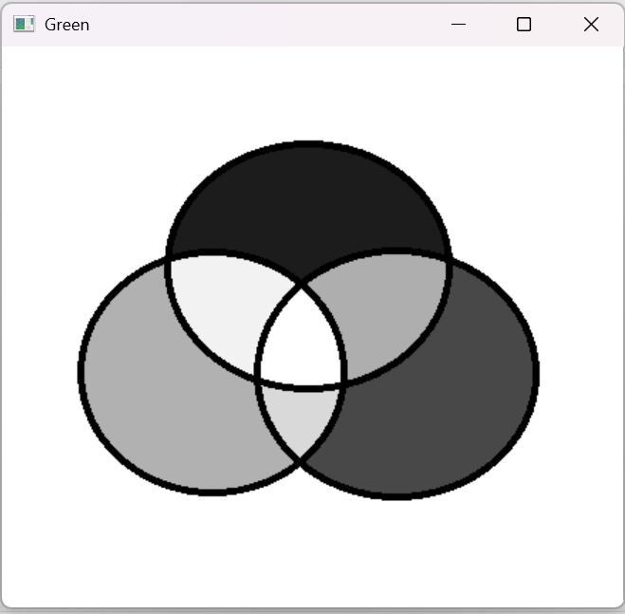

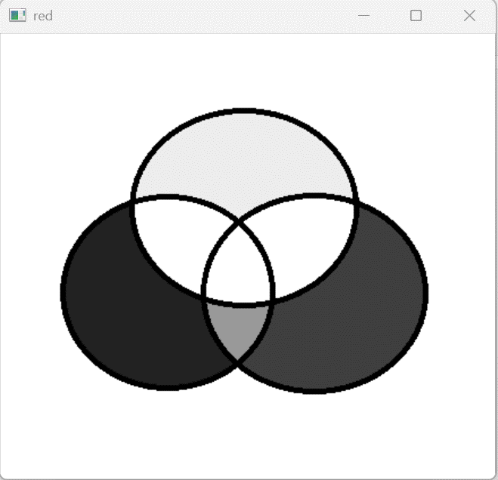

### ***2.2 Image Processing***

# *Image Resizing using Open-CV | Python*

# *Image resizing refers to the scaling of images. Scaling comes in handy in many image processing as well as machine learning applications. It helps in reducing the number of pixels from an image and that has several advantages e.g. It can reduce the time of training of a neural network as the more the number of pixels in an image more is the number of input nodes that in turn increases the complexity of the model.*

# 

# *Output:*

# 

# *Eroded Image:*

# 

* ***Output:***



* ***Blurring an Image:***

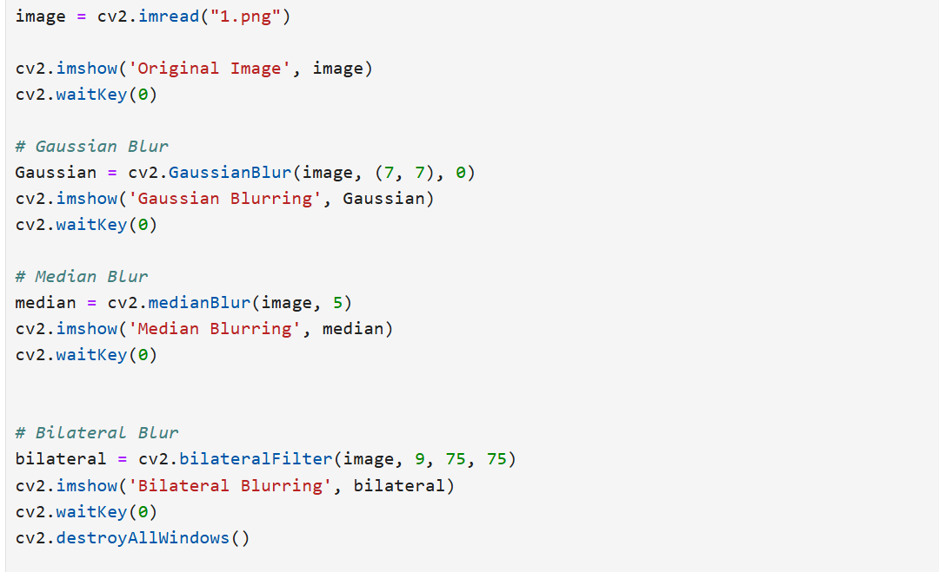

* ***Output:***

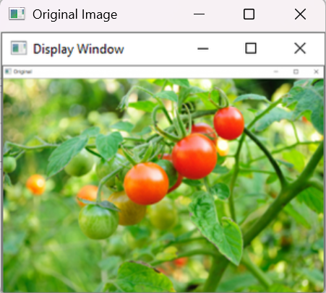

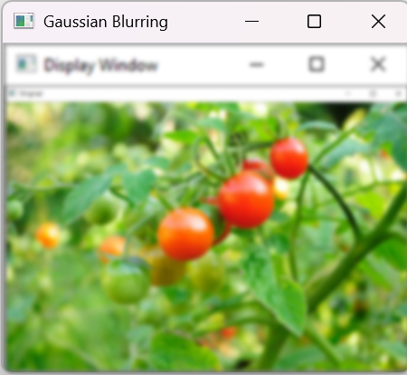

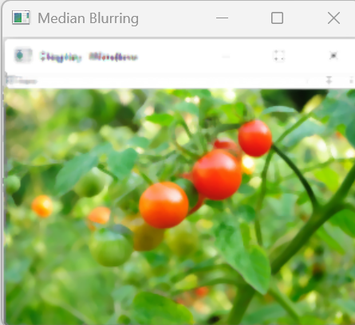

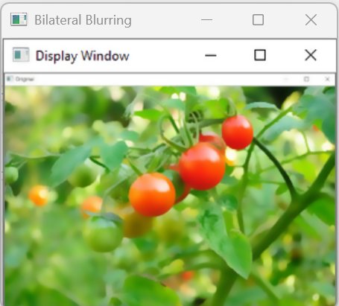

* ***Create Border around Images:***

***OpenCV-Python****is a library of Python bindings designed to solve computer vision problems. cv2.copyMakeBorder() method is used to create a border around the image like a photo frame.*

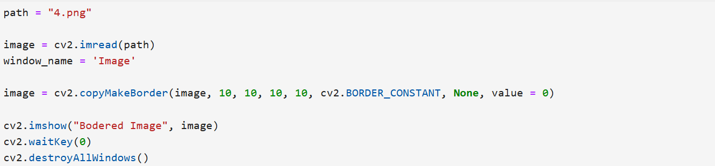

* ***Output:***



* ***Simple Thresholding***

***Thresholding****is a technique in OpenCV, which is the assignment of pixel values in relation to the threshold value provided. In thresholding, each pixel value is compared with the threshold value. If the pixel value is smaller than the threshold, it is set to 0, otherwise, it is set to a maximum value (generally 255). Thresholding is a very popular segmentation technique, used for separating an object considered as a foreground from its background. A threshold is a value which has two regions on its either side i.e. below the threshold or above the threshold.*

# *Output:*

# 

# 

# 

* [***Filter Color with OpenCV***](https://www.geeksforgeeks.org/filter-color-with-opencv/)

*identifying specific objects/regions having a specific color. The most widely used color space is RGB color space, it is called an****additive color space****as the three color shades add up to give color to the image. To identify a region of a specific color, put the threshold and create a mask to separate the different colors. HSV color space is much more useful for this purpose as the colors in HSV space are much more localized thus can be easily separated. Color Filtering has many applications and uses cases such as in Cryptography, infrared analysis, food preservation of perishable foods, etc. In such cases, the concepts of Image processing can be used to find out or extract out regions of a particular color.*

# *Output:*

# *For this one it’s a video so you have to try it yourself.*

* ***Convert an image from one color space to another***

*OpenCV provides the cv2.cvtColor() function to convert an image from one color space to another. A common use is converting an image from BGR (Blue, Green, Red), which is how OpenCV reads images by default, to RGB or to grayscale.*

# *Output:*

# 

* ***Image Translation***

***Translation****refers to the rectilinear shift of an object i.e. an image from one location to another. If we know the amount of shift in horizontal and the vertical direction, say (tx, ty) then we can make a transformation matrix e.g. [1 0 tx]*

*0 1 ty] where tx denotes the shift along the x-axis and ty denotes shift along the y-axis i.e. the number of pixels by which we need to shift about in that direction.*

* ***Output:***

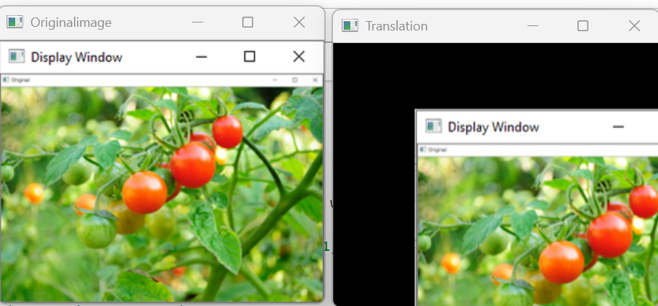

* ***Image Pyramid***

***Image Pyramids****are one of the most beautiful concept of image processing. Normally, we work with images with default resolution but many times we need to change the resolution (lower it) or resize the original image in that case image pyramids comes handy.*

# *Output:*

# 

# 

# 

# 

### ***Feature Detection and Description***

* ***Line detection using Houghline method***

*The Hough Transform is a method that is used in image processing to detect any shape, if that shape can be represented in mathematical form. It can detect the shape even if it is broken or distorted a little bit.  
We will see how Hough transform works for line detection using the HoughLine transform method. To apply the Houghline method, first an edge detection of the specific image is desirable. For the edge detection technique go through the article Edge detection*

* ***Output:***



* ***Circle Detection***

*Circle detection finds a variety of uses in biomedical applications, ranging from iris detection to white blood cell segmentation.*

* ***Output***

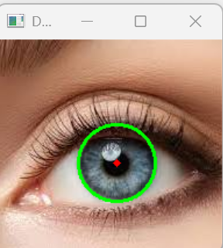

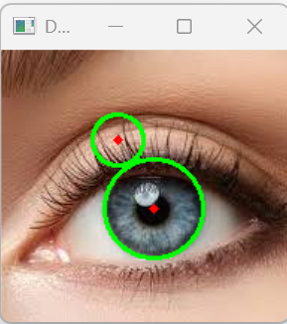

* ***Detect corner of an image***

*Let’s see how to detect the corner in the image.*

*cv2.goodFeaturesToTrack() method finds N strongest corners in the image by Shi-Tomasi method. Note that the image should be a grayscale image. Specify the number of corners you want to find and the quality level (which is a value between 0-1). It denotes the minimum quality of corner below which everyone is rejected. Then provide the minimum Euclidean distance between corners detected.*

* ***Output***

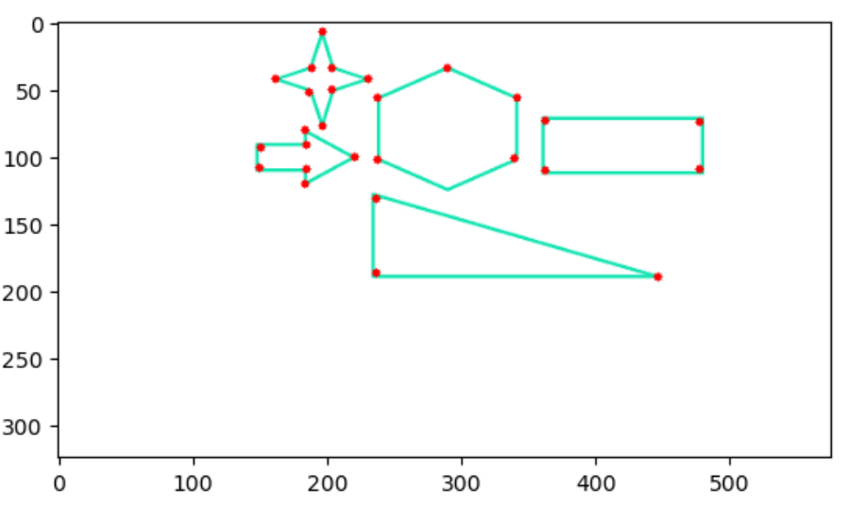

* ***Corner Detection with Shi-Tomasi method***

*Shi-Tomasi Corner Detection was published by J.Shi and C.Tomasi in their paper ‘Good Features to Track‘. Here the basic intuition is that corners can be detected by looking for significant change in all direction.*

*We consider a small window on the image then scan the whole image, looking for*

*corners.*

* ***Output***

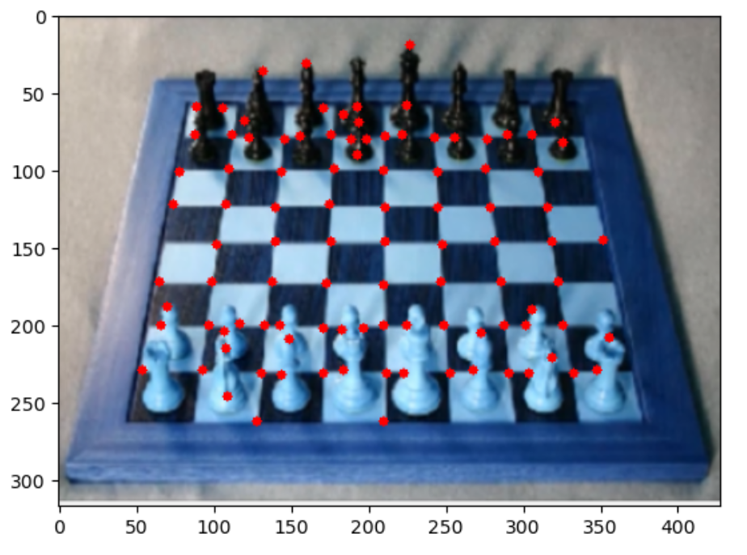

* ***Corner detection with Harris Corner Detection***

***Harris Corner detection****algorithm was developed to identify the internal corners of an image. The corners of an image are basically identified as the regions in which there are variations in large intensity of the gradient in all possible dimensions and directions. Corners extracted can be a part of the image features, which can be matched with features of other images, and can be used to extract accurate information. Harris Corner Detection is a method to extract the corners from the input image and to extract features from the input image.*

* ***Output***

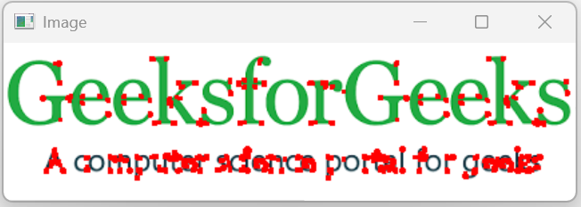

* ***Find Circles and Ellipses in an Image***

*To identify circles, ellipses, or in general, any shape in which the pixels are connected we use the****SimpleBlobDetector()****function of OpenCV. In non-technical terms, a blob is understood as a thick liquid drop. Here, we are going to call all shapes a blob. Our task is to detect and recognize whether the blob is a circle or not.*

* ***Output***

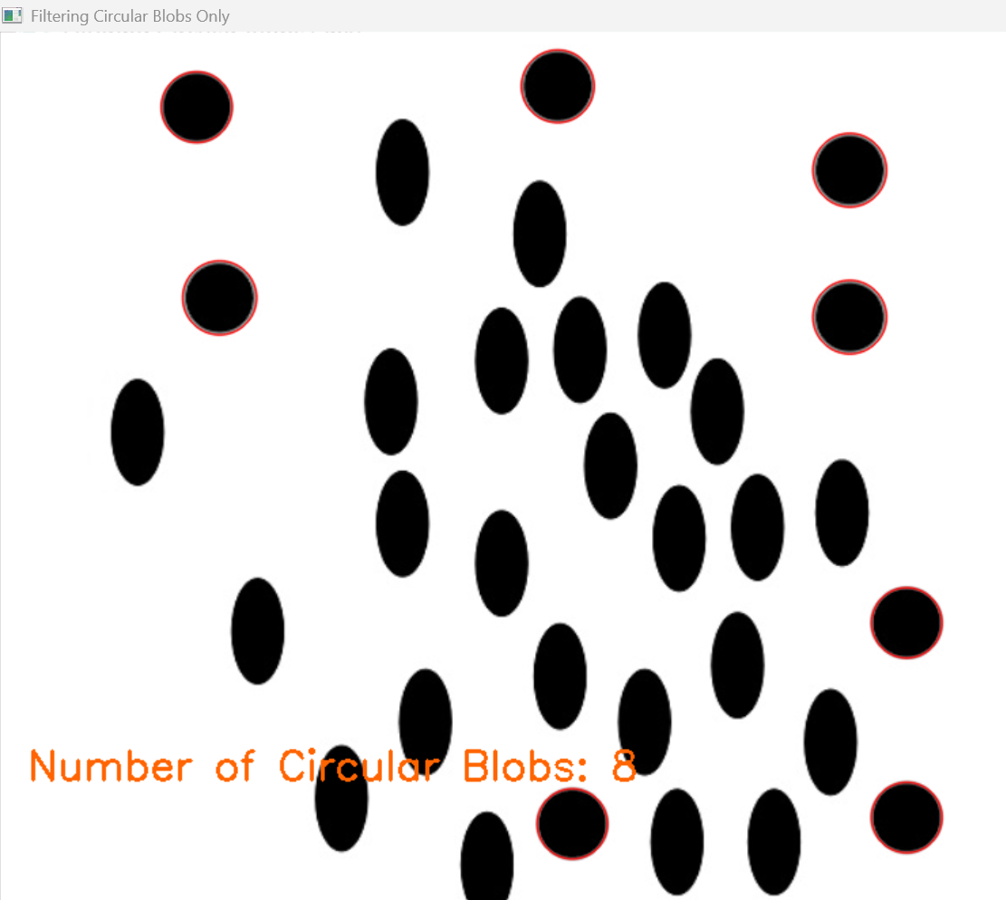

### ***2.4 Drawing Functions***

* ***Draw a line***

***OpenCV-Python****is a library of Python bindings designed to solve computer vision problems. cv2.line() method is used to draw a line on any image.*

* ***Output:***



* ***Draw arrow Segment***

***OpenCV-Python****is a library of Python bindings designed to solve computer vision problems.   
cv2.arrowedLine() method is used to draw arrow segment pointing from the start point to the end point.*

* ***Output***



* ***Draw an ellipse***

***OpenCV-Python****is a library of Python bindings designed to solve computer vision problems. cv2.ellipse() method is used to draw a ellipse on any image.*

* ***Output***



* ***Draw a circle***

***OpenCV-Python****is a library of Python bindings designed to solve computer vision problems. cv2.circle() method is used to draw a circle on any image.*

* ***Output***



* ***Draw a rectangle***

***OpenCV-Python****is a library of Python bindings designed to solve computer vision problems. cv2.rectangle() method is used to draw a rectangle on any image.*

* ***Output***



* ***Draw a text string***

***OpenCV-Python***

*is a library of Python bindings designed to solve computer vision problems.*

*cv2.putText()*

*method is used to draw a text string on any image.*

* ***Output***



# *Find and Draw Contours*

***Contours****are defined as the line joining all the points along the boundary of an image that are having the same intensity. Contours come handy in shape analysis, finding the size of the object of interest, and object detection.*

*OpenCV has findContour() function that helps in extracting the contours from the image. It works best on binary images, so we should first apply thresholding techniques, Sobel edges, etc.*

* ***Output***

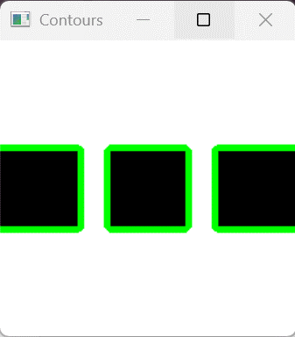

# *Draw a triangle with centroid*

# ***Prerequisite:****Geometric shapes using OpenCV Given three vertices of a triangle, write a Python program to find the centroid of the triangle and then draw the triangle with its centroid on a black window using OpenCV.*

* ***Output***

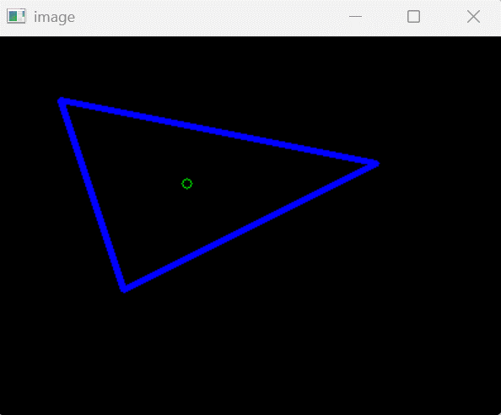

## ***3. Working with Videos***

### ***3.1 Getting Started***

* ***Play a video using Opencv***

***OpenCV****(Open Source Computer Vision) is a computer vision library that contains various functions to perform operations on Images or videos. OpenCV library can be used to perform multiple operations on videos.*

*Let’s see how to play a video using the OpenCV Python. To capture a video, we need to create a VideoCapture object. VideoCapture have the device index or the name of a video file. Device index is just the number to specify which camera. If we pass 0 then it is for*first camera*, 1 for*second camera*so on. We capture the video frame by frame.*

* ***Output***

*The output can be seen by running the code provided in the code file*

***3.2 Video Processing***

* ***Creating video using multiple images***

*Creating videos from multiple images is a great way for creating time-lapse videos. In this tutorial, we’ll explore how to create a video from multiple images using Python and OpenCV.****Creating a video from images involves combining multiple image frames, each captured at a specific moment in time, into a single video file.***

* ***Output***

*The output can be seen by running the code provided in the code file*

* ***Extract images from video***

*OpenCV comes with many powerful video editing functions. In current scenario, techniques such as image scanning, face recognition can be accomplished using OpenCV.*

*Image Analysis is a very common field in the area of Computer Vision. It is the extraction of meaningful information from videos or images. OpenCv library can be used to perform multiple operations on videos.*

* ***Output***

*The output can be seen by running the code provided in the code file*